VNU-HCM International University



TRAIN TICKET MANAGEMENT
Final Project Report
Subject: Web Application Development
Instructor: Nguyen Trung Nghia

Group Members: 1. Le Nhat Duy - ITITWE22143
- Nguyen Dinh Minh Quan – ITITWE22178

December 2025
Contents
I. Introduction
1.1 Project Overview
1.2 Objectives
1.3 Scope
1.4 Technologies Used
II. Requirement Analysis
2.1 Actors
2.2 Use Cases & Functional Requirements
2.2.1 UC01 – Search Train (Enquiry)
2.2.2 UC02 – View Search Result
2.2.3 UC03 – Booking (Create Reservation)
2.2.4 UC04 – Add Passenger Details
2.2.5 UC05 – Payment (QR / COD / Card)
2.2.6 UC06 – My Tickets
2.2.7 UC07 – Cancel Ticket
2.3 Non-Functional Requirements
III. System Design
3.1 System Architecture (Simple 3-tier)
3.2 Database Design (ERD Description)
IV. Flow Code
4.1 Main Functional Flow
4.2 Payment Module (QR)
4.3 My Tickets – Display Payment Status
4.3 My Tickets – Display Payment Status
V. Discussion & Conclusion
6.1 Achievements
6.2 Limitations
6.3 Future Enhancements
VI. References

I. Introduction
1. Project Overview
The Railway Reservation System is a web application that allows users to search for trains, book tickets, enter passenger information, choose a payment method (QR/COD/Card), and view booked tickets. The system uses a MySQL database to store information about stations, train schedules, seat classes, available seats, reservations (PNR), passenger details, and payment status.
2. Objectives
- Provide a complete booking flow from Station A to Station B by selected date.
- Manage remaining seats based on seat class and route.
- Generate a unique PNR for each reservation.
- Integrate basic payment flow:
+ QR payment is shown using the internal project image qr.png (not an external URL).
+ Save payment records on the payments table.
- Allow users to view tickets (My Tickets) and display Payment Status.
- Support ticket cancellation and automatically restore seats / compute refunds using database triggers.
3. Scope
+ Register user: Search → Booking → Passenger Details → Payment → My Tickets → Cancel Ticket
+ Admin: Manage train/station/schedule/class seats data
4. Technologies Used
Frontend: HTML/CSS, Bootstrap
Backend: PHP
Database: MySQL
Local environment: XAMPP and phpMyAdmin
II. Requirement Analysis
1. Actors
- Registered User: Book tickets, view tickets, cancel tickets, and track payment status.
- Admin: Manage master data (train, station, schedule, class seats).
2. Use Cases & Functional Requirements
UC01 – Search Train (Enquiry)
Allow user to search the train without registered but not allow booking if user isn’t register
Functional Requirements:
Display station list (from station table).
User selects sp, dp, doj.
Return matching train results with departure/arrival time, class, fare, and remaining seats.
UC02 – View Search Result
Functional Requirements:
Show result table: Train No, Name, Departure, Arrival, Class, Fare, Seats Left.
Allow users to choose Train + Class and number of seats to book.
UC03 – Booking (Create Reservation)
Functional Requirements:
Validate booking rules (e.g., at least one adult ≥ 18).
Create a reservation record in resv (PNR auto generated).
Decrease seats left in classseats.
UC04 – Add Passenger Details
Functional Requirements:
Input passenger list based on nos.
Save to pd (pnr, pname, page, pgender).
UC05 – Payment (QR / COD / Card)
Functional Requirements:
User selects payment method.
If QR, display internal image qr.png from the project folder.
Save payment record into payments.
UC06 – My Tickets
Functional Requirements:
User logs in using mobile and password.
Display bookings from resv.
Display payment status to payments.
UC07 – Cancel Ticket
Functional Requirements:
User enters PNR to cancel (must belong to the logged-in user).
Update resv.status: showing ‘Cancelled’.
Trigger automatically handles:
Block cancellation if journey date has passed.
Restore seats to classseats.
Insert refund record to canc (pnr, rfare) based on refund rules.
3. Non-Functional Requirements
Security: Use prepared statements for sensitive operations (e.g., login) to prevent SQL injection.
Reliability: Reservation and payment data must remain consistent; triggers enforce cancellation rules automatically.
Usability: Clear, responsive UI using Bootstrap and user-friendly error messages.
Maintainability: Separate PHP files by feature (enquiry, result, booking, payment, tickets, cancel).
III. System Design
    - Use Case Diagram
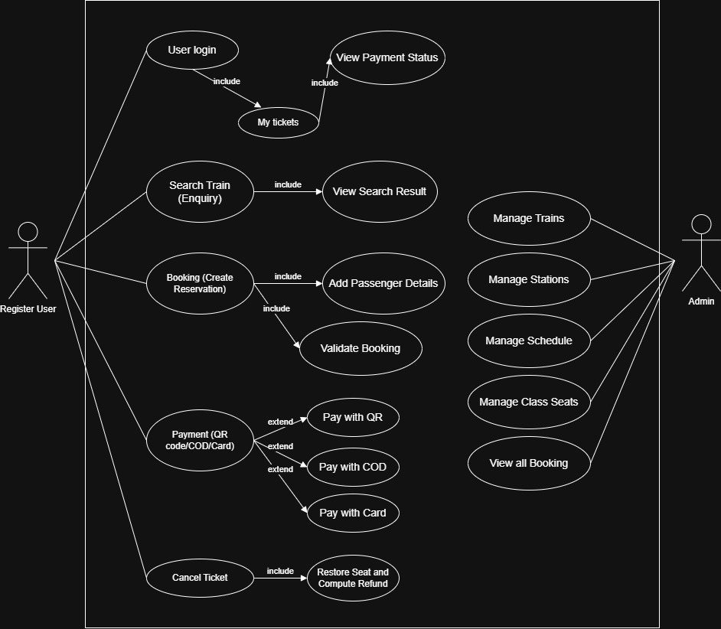

2. Database Design (ERD Description)
Main tables:
- user(id, mobileno, password, emailid, …)
- station(id, sname)
- train(trainno, tname, dd, …)
- schedule(trainno, sname, departure_time/arrival_time, …)
- classseats(trainno, sp, dp, doj, class, fare, seatsleft)
- resv(pnr, id, trainno, sp, dp, doj, tfare, class, nos, status)
- pd(pnr, pname, page, pgender)
- payments(pnr, method, status, txn_ref, created_at, …)
- canc(pnr, rfare)
Key relationships:
- user (1) → (n) resv
- resv (1) → (n) pd
- resv (1) → (0..1) payments (a ticket may not be paid yet)
- resv (1) → (0..1) canc (one cancellation may create one refund record)
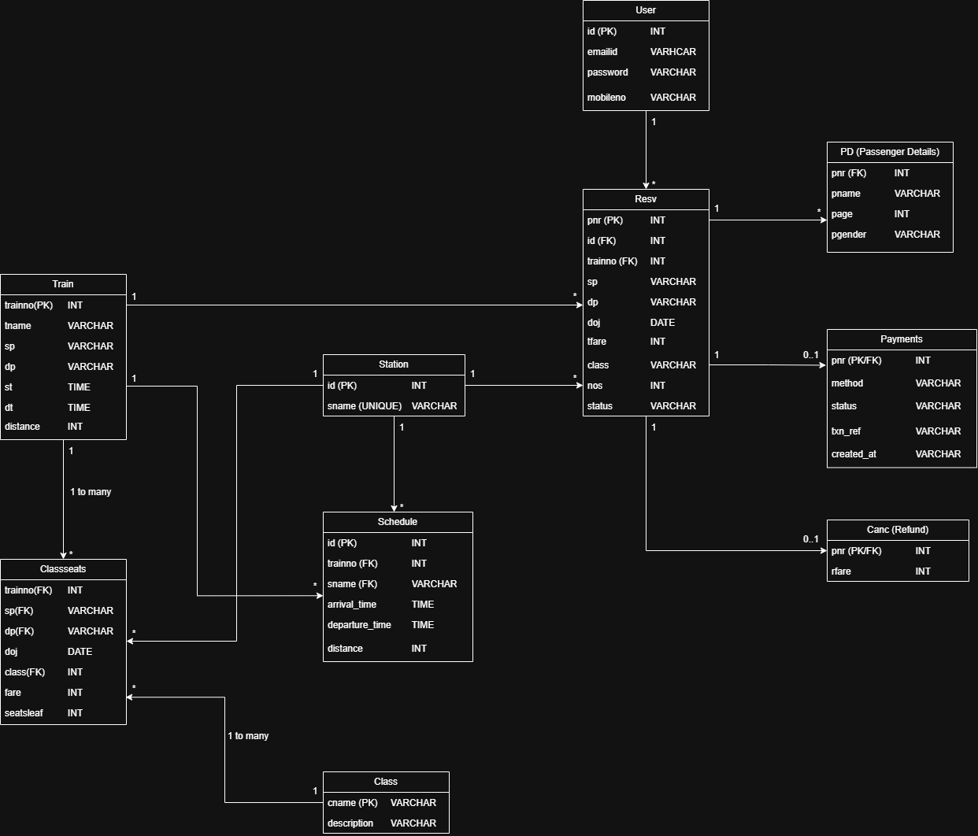
    - Sequence Diagram

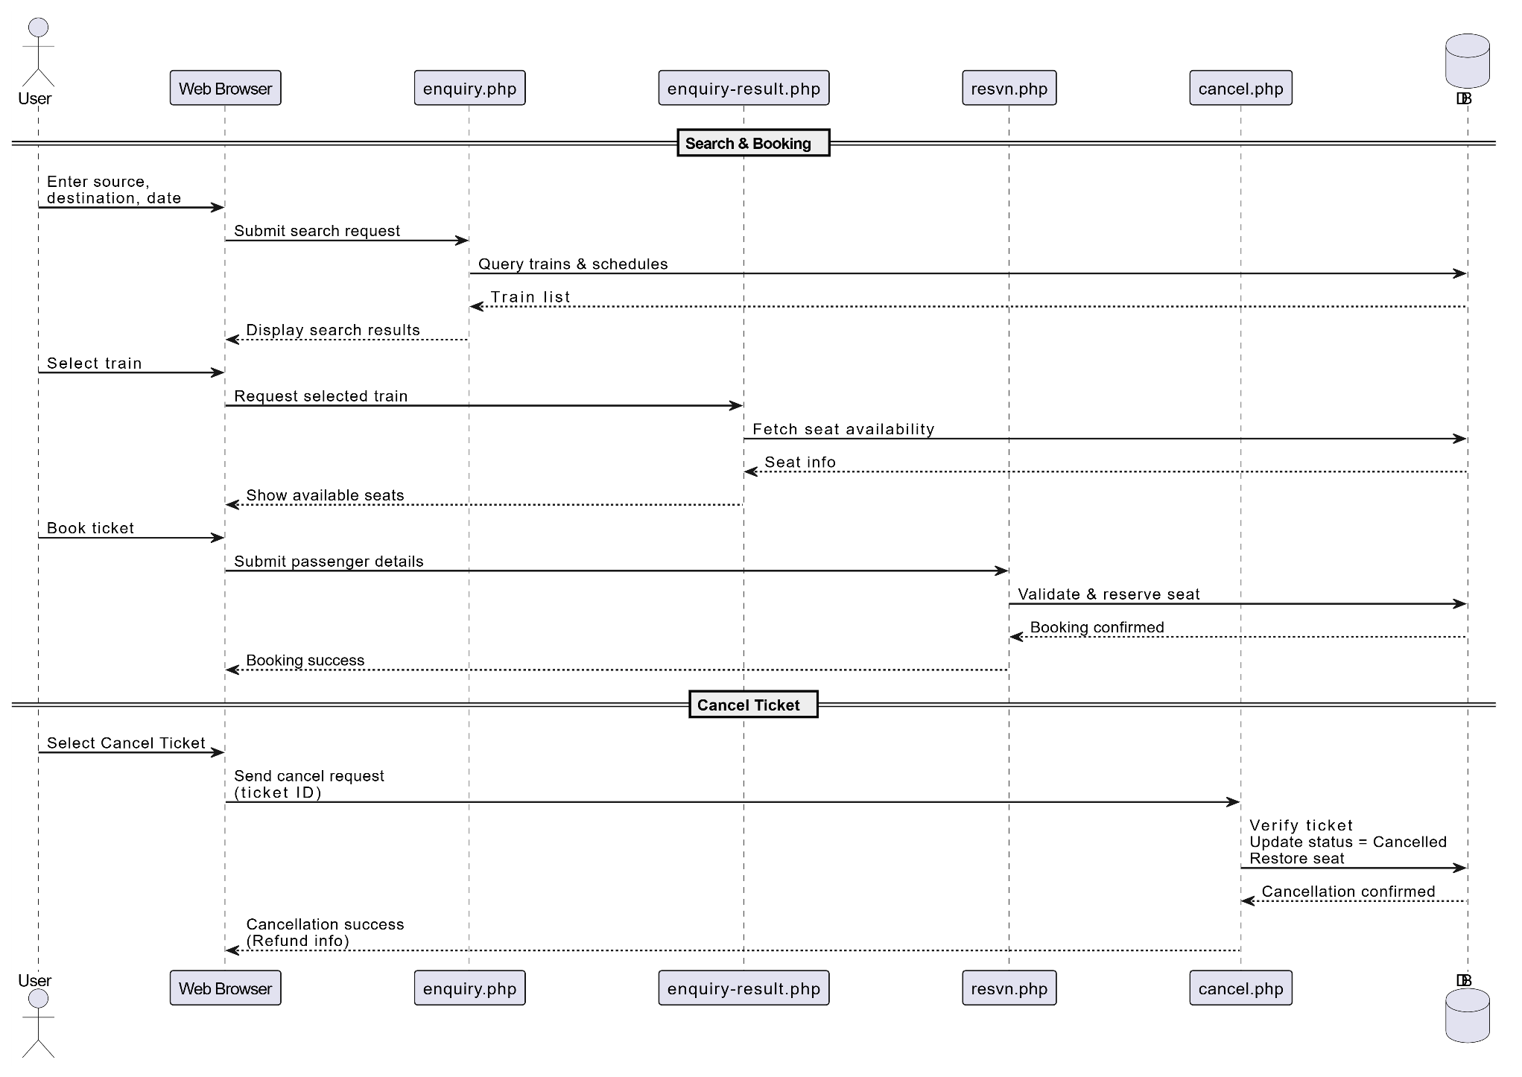

IV. Flow Code
1. Main Functional Flow
index.html (first start UI): including all main functions of the train ticket web. Entry point of all system. When users click a feature button:
  - Register: redirects to the registration page to create a new user account.
  - Book ticket: starts the booking process (search, choose train, enter passenger details, payment)
  - My tickets: opens the login + ticket history page where users can view bookings and payment status.
  - Admin: login as admin account, allows administrators to manage system data (stations, trains, schedules, class seats).
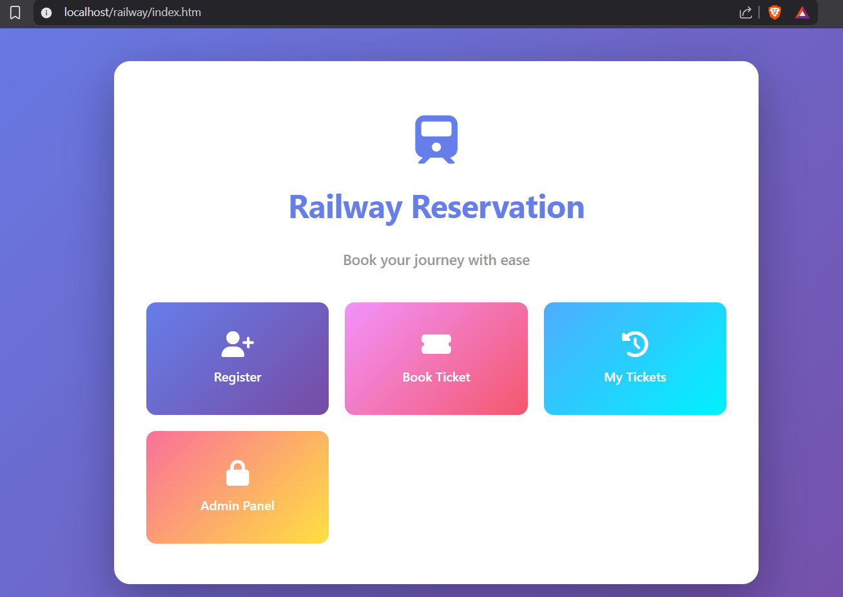

Book Ticket (enquire.php): allow people to choose the starting point, destination point and the date to search for available train that occurs on that date.
Starting with creating session by session.start() so the system can store the user’s search data and reuse it in later pages. After that we need to use require “db.php” to loads the database connection so the page can query stations from MySQL. Then we call method from SQL: “SELECT sname FROM station” to fetches the list of available stations from the station table to populate the FROM and TO dropdowns. With id: sp (starting point), dp (destination point) and doj (date of journey) allow user to selected and the system will compare the user’s selection to database to show the suitable outcome after user click Search. Search buttons will POST to enquire_result.php which can submit the search criteria to the results page to retrieve matching trains. 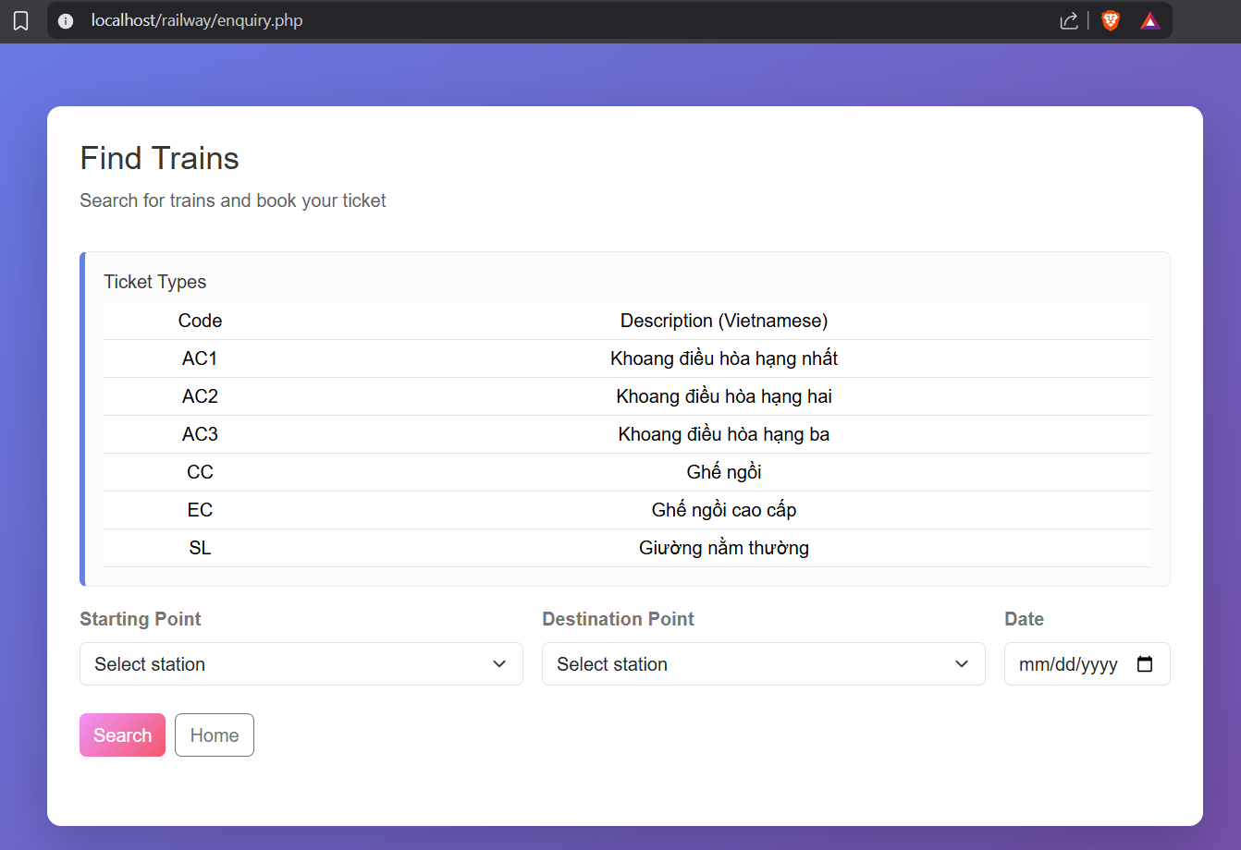
enquiry_result.php (after complete action at Book Ticket – enquire.php): show search result and booking form
Just like enquire.php, we will call session first using session_start(); continues the session so the page can store the search values for later booking steps. After that, we ues require “db.php” to enables database queries to fetch train results and seat/fare data. Because the user choosed id: sp, dp and doj at the previous enquire.php, so this web pages will read the inputs to retrieves the user’s search criteria sent from enquiry.php. System will save the search inputs into session using code function from line 5 to line 10, this also keeps the journey info across multiple pages (so the user does not re-enter it).
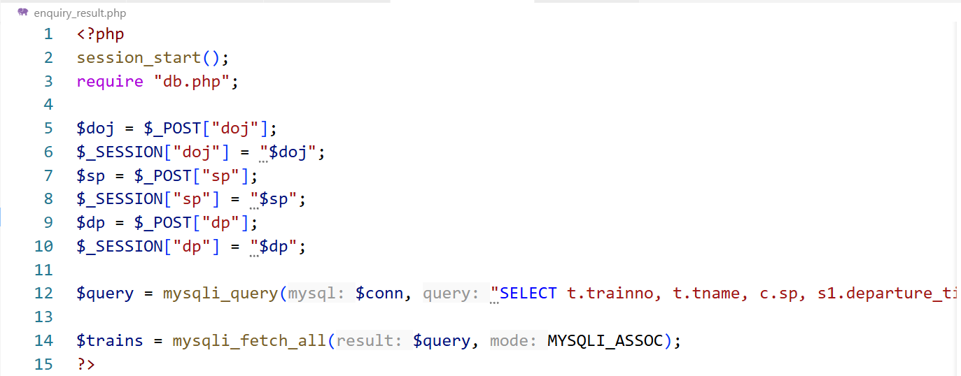
Then we use the function at line 12 to return train options that match the route and date, including: train number/name, class, fare per seat, seats left and it will show all available trains for the selected route/date so the user can choose one. We create some options for customers like selecting trains and payment methods to collect booking preferences before moving to passenger details. At payment methods, if user choose QR code, it will show the QR scan for them. After all, user clicks the Proceed with booking, it will send booking preferences to the passenger details page (resvn.php).
resvn.php (after user click Proceed with booking – enquire_result.php):
First, we call session to read existing session values from the previous pages. This page will read data booking from enquire_result.php through variables id, tno, class, nos and get the user’s chosen train/class/seats to show up in html. Then we save booking data to session (line 23 to 35) for the next page (new_png.php) and next page will insert the booking into the database using these session values. We create a place for users to insert their data like name age gender and collected it for each seat booked. After user done all of that, they click Confirm Booking, it will submit all passenger arrays + booking data for database insertion and move to new_png.php
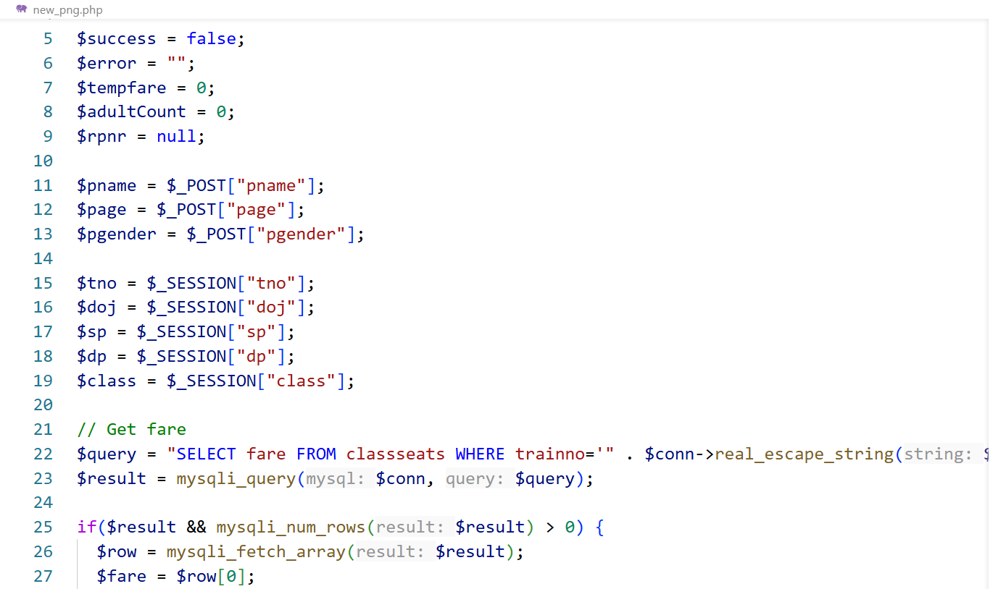
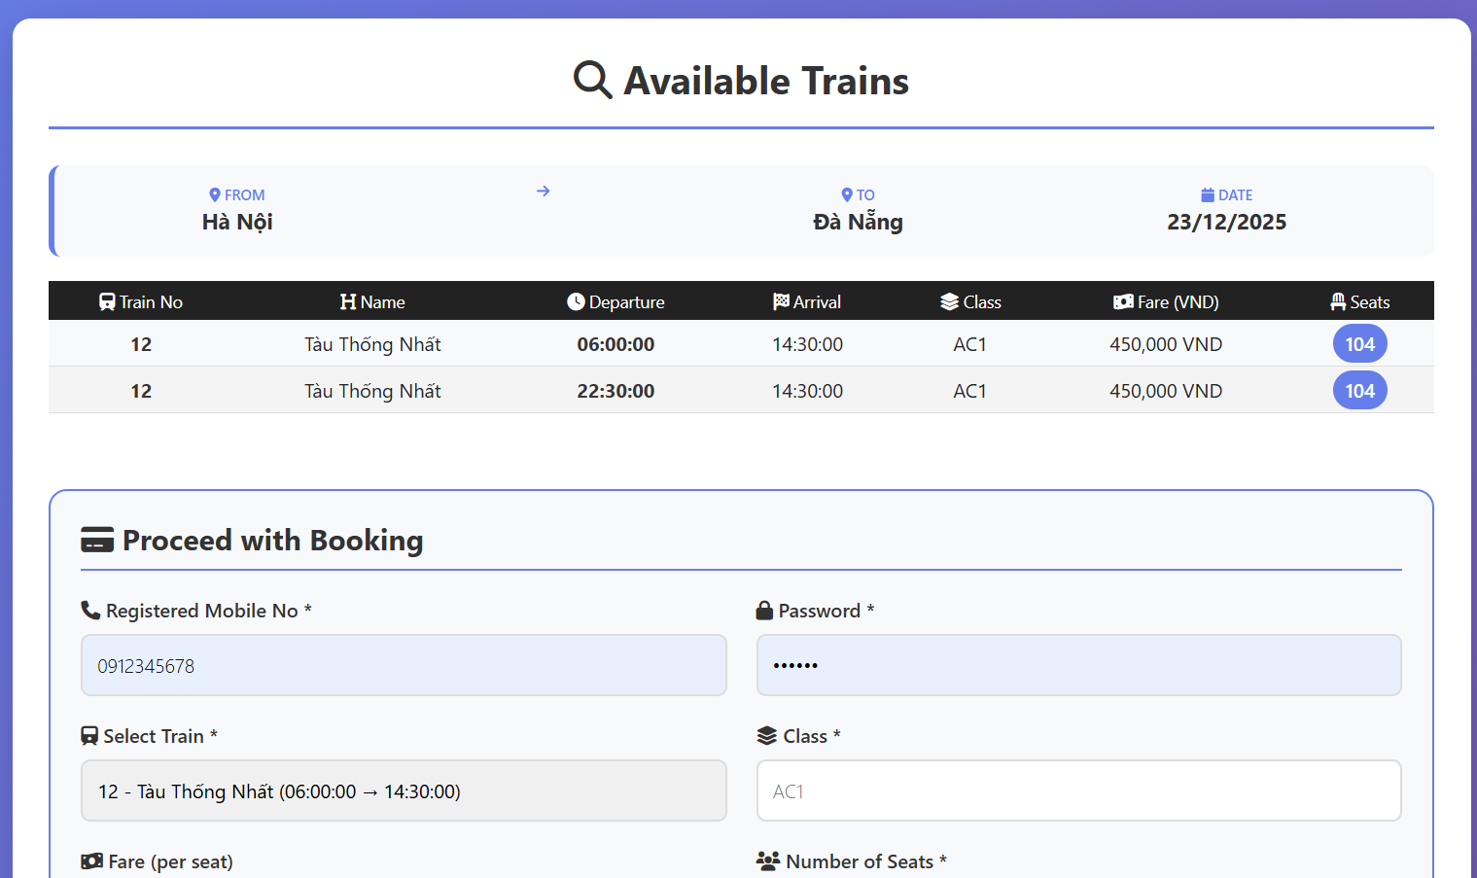
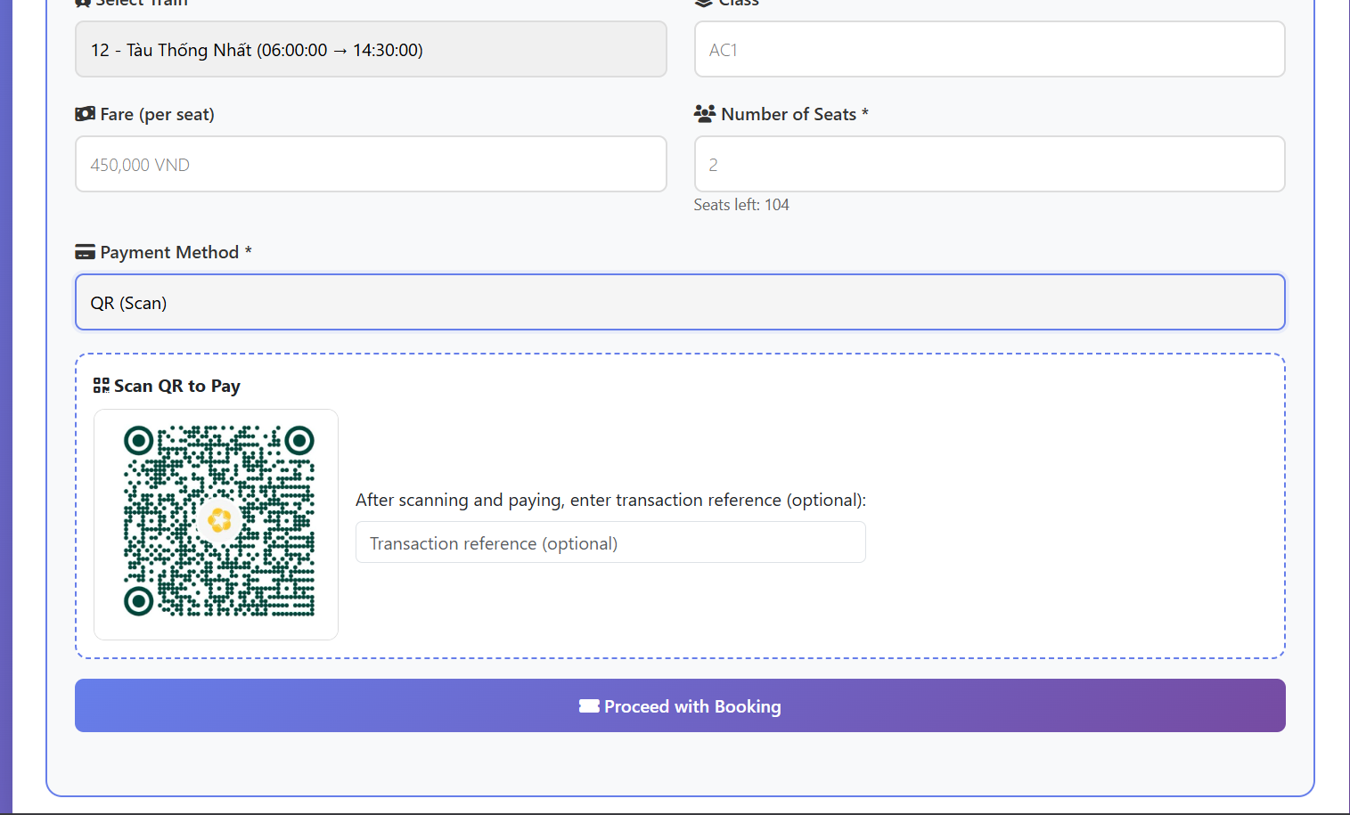
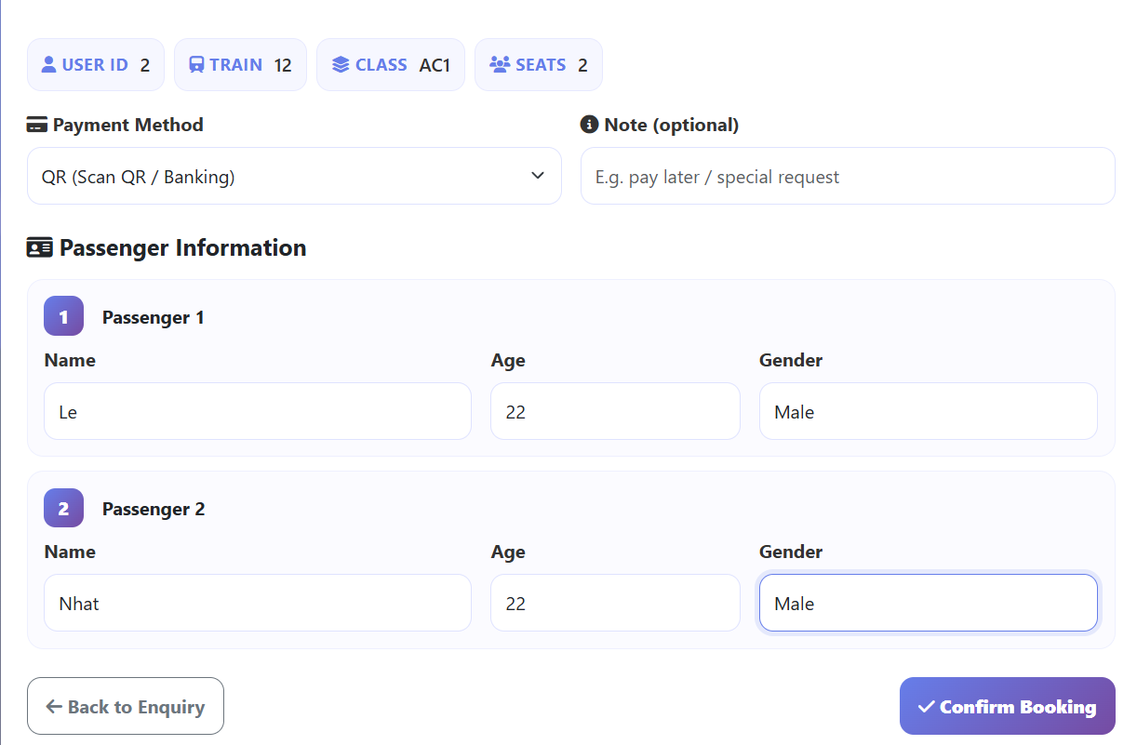
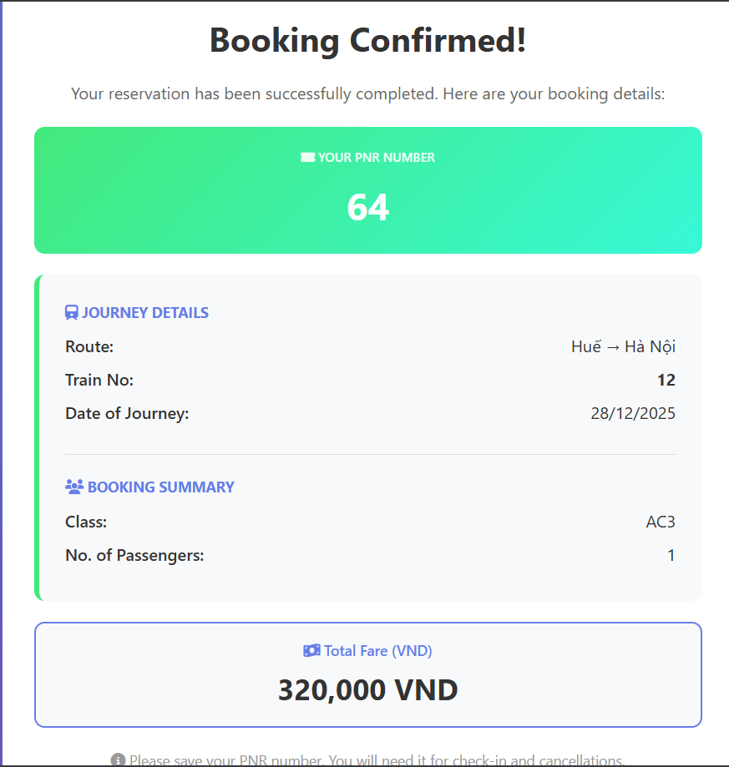
Booking Creation Flow (new_png.php):
First, use session_start() to retrieves booking context from previous steps (user ID, train/class, journey, seats). Then use require “db.php” to enables all INSERT/UPDATE SQL queries. Then it will read passenger input arrays through pname[], page[], pgender[] to prepare details to insert into table pd. Then it will read booking data from session tno, sp, dp, doj, class, nos, id to prepares data for inserting the reservation into table resv (line 68 to 76).

for($i = 0; $i < $_SESSION["nos"]; $i++) {
if($page[$i] >= 18) {
$adultCount++;
$tempfare += $fare;
} else if($page[$i] < 18) {
$tempfare += 0.5 * $fare;
}
}

// Check for at least one adult
if($adultCount > 0) {
// Insert reservation
$sql = "INSERT INTO resv(id, trainno, sp, dp, doj, tfare, class, nos) VALUES ('" . $_SESSION["id"] . "', '" . $conn->real_escape_string($tno) . "', '" . $conn->real_escape_string($sp) . "', '" . $conn->real_escape_string($dp) . "', '" . $conn->real_escape_string($doj) . "', '" . $tempfare . "', '" . $conn->real_escape_string($class) . "', '" . $_SESSION["nos"] . "')";

if ($conn->query($sql) === TRUE) {
// Get the PNR
$query = "SELECT pnr FROM resv WHERE id='" . $_SESSION["id"] . "' AND trainno='" . $conn->real_escape_string($tno) . "' AND doj='" . $conn->real_escape_string($doj) . "' ORDER BY pnr DESC LIMIT 1";
$result = mysqli_query($conn, $query);
$row = mysqli_fetch_array($result);
$rpnr = $row['pnr'];

// Insert passenger details
$passengerInsertSuccess = true;
for($i = 0; $i < $_SESSION["nos"]; $i++) {
$sql = "INSERT INTO pd(pnr, pname, page, pgender) VALUES ('" . $rpnr . "', '" . $conn->real_escape_string($pname[$i]) . "', '" . $page[$i] . "', '" . $conn->real_escape_string($pgender[$i]) . "')";
if ($conn->query($sql) !== TRUE) {
$passengerInsertSuccess = false;
$error = $conn->error;
break;
}
}

if($passengerInsertSuccess) {
$success = true;
}
} else {
$error = $conn->error;
}
} else {
$error = "At least one adult (age 18+) must accompany the group!";
}
} else {
$error = "Could not retrieve fare information. Please try again.";
}
Then it gets fare from classeats to obtain the correct fare per seat based on train/class/route/data (line 37 to 42). Then we continue to calculate fare through aged that user send (line 51 to 59), loop through passengers: age >= 18 is full fare, otherwise is 50% fare and we have to make sure that the passengers include adult by checking adultcount > 0 (line 62) to ensure that there are at least one adult must be included in the group. Then we will insert data into resv table (line 68 to 76) to create main booking record (the system will generate random and unique pnr at the same time). PNR generation (line 81 to 88) - get the new pnr so it can be used to link passengers and payments to this reservation. Then it will insert passengers’ rows into pd, it creates the statement $passengerInsertSuccess = true first, then insert passengers’s details (line 97 to 101). After that, it will use the statements to check if it still true or false, if it true: it will insert payment row to pd(line 115) in order to stores passenger information linked to the reservation PNR. Then insert payment record into payments (line 129 – 131) so that can save payment stat per ticket so My Tickets can display payment status later. After all, show booking confirmation UI and give the user PNR.
Login + My Tickets Flow (user_login.php):
Case 1: user not logged yet.
Show login form and call session for preparation usage (to store user ID after login)
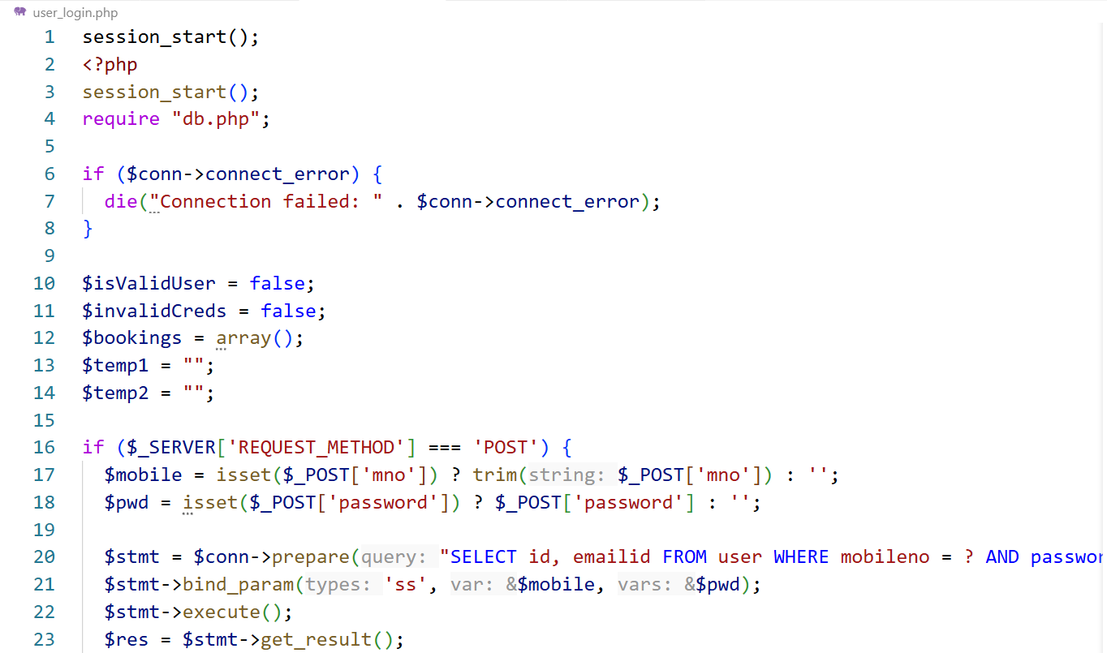
Case 2: user is login.
Read input (line 16, 17) to receive user credentials from the login form. Then prepare statement user validation to check the credentials securely and prevents SQL injection (line 20). Check if credentials are correct, it will marks login success and stores the user ID to identify the user in future action (line 25 - 33). Then load ticket history with payment status (line 45 – 54) fetched all reservation for the logged-in user and attaches payment details per ticket. After successful login, user can see the system had already render the ticket with PNR, train, date, etc…
Cancel Ticket Flow (cancel.php):
First, session_start() for reading logged-in user ID from session. Then require "db.php" to enable database update queries. Then system will read PNR from Post (line 5) to identify which booking the user wants to cancel and read user ID from session (line 6) to ensure the user can only cancel their own reservation. System will initialize result flags to prepare variables to show success/failure message on the result page (line 8, 9). Then system will validate some require value like user ID or PNR, if user id is missing or PNR is empty it will activate line 12, it helps prevent running SQL when input/session is invalid. System will check current booking status after that, this is important step with statement line 16, the system will confirm that PNR exists, the ticket belongs to the right user, read the current status (BOOKED or CANCELLED). If the PNR does not exist or the ticket belongs to the wrong user, it will alert (line 21-22), user cannot cancel the ticket that does not belong to them. And if the ticket has already CANCELLED (line 25) it will print line 26 to avoid cancelling the same ticket and triggering database logic (trigger can cause duplicate refund). If it does not meet any condition above, the system will update status that ticket has been cancelled (line 29). After all, show result page (HTML), if $success == true: show “Cancellation Successful” (line 147-151), else show “Cancellation Failed” and display error message.
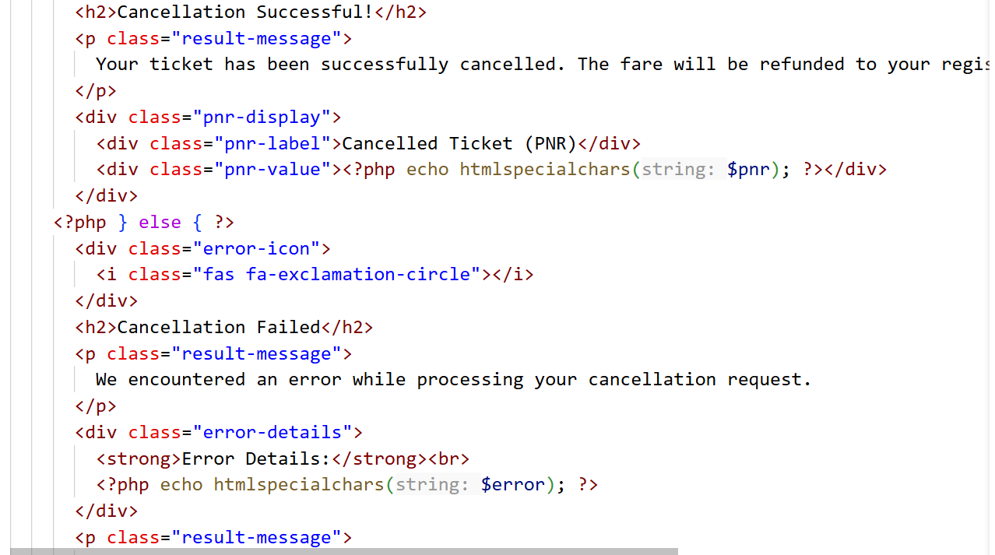
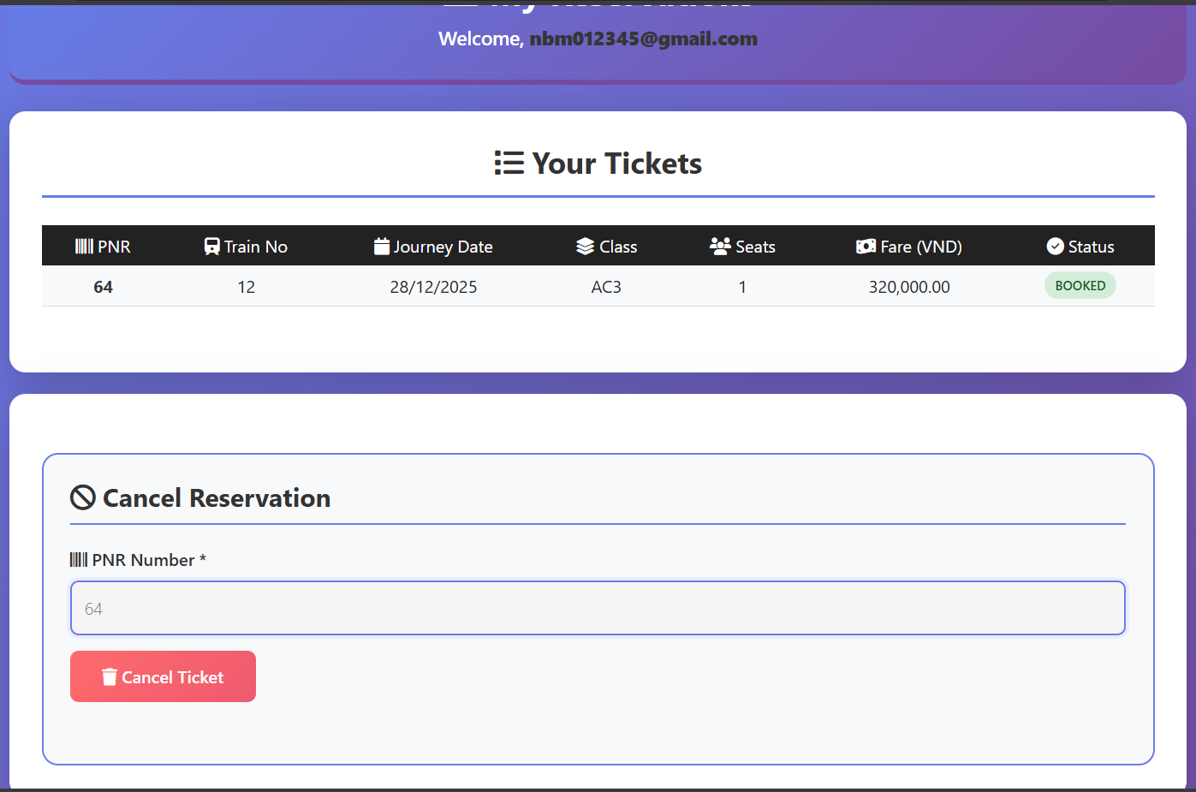
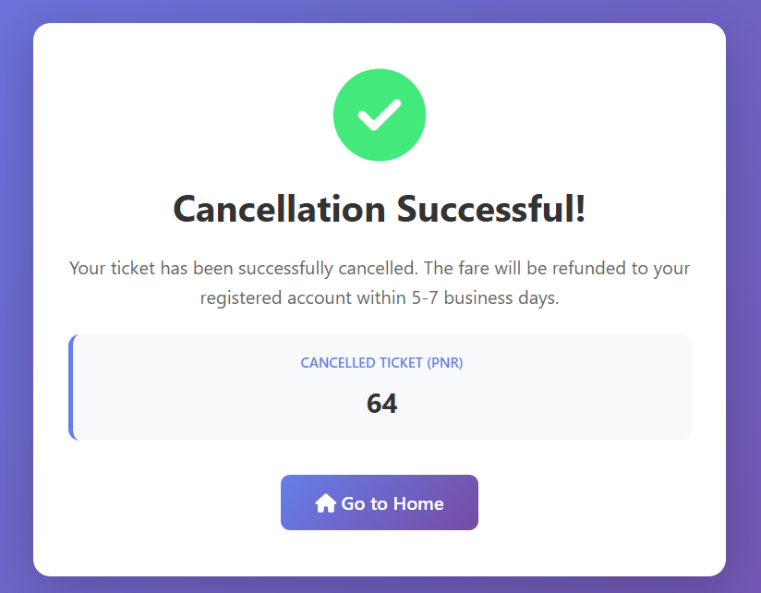
4.4 Admin function
Session Initialization
Starting by calling session_start() to enable session management. This allows the system to store and retrieve the admin login state across multiple pages.
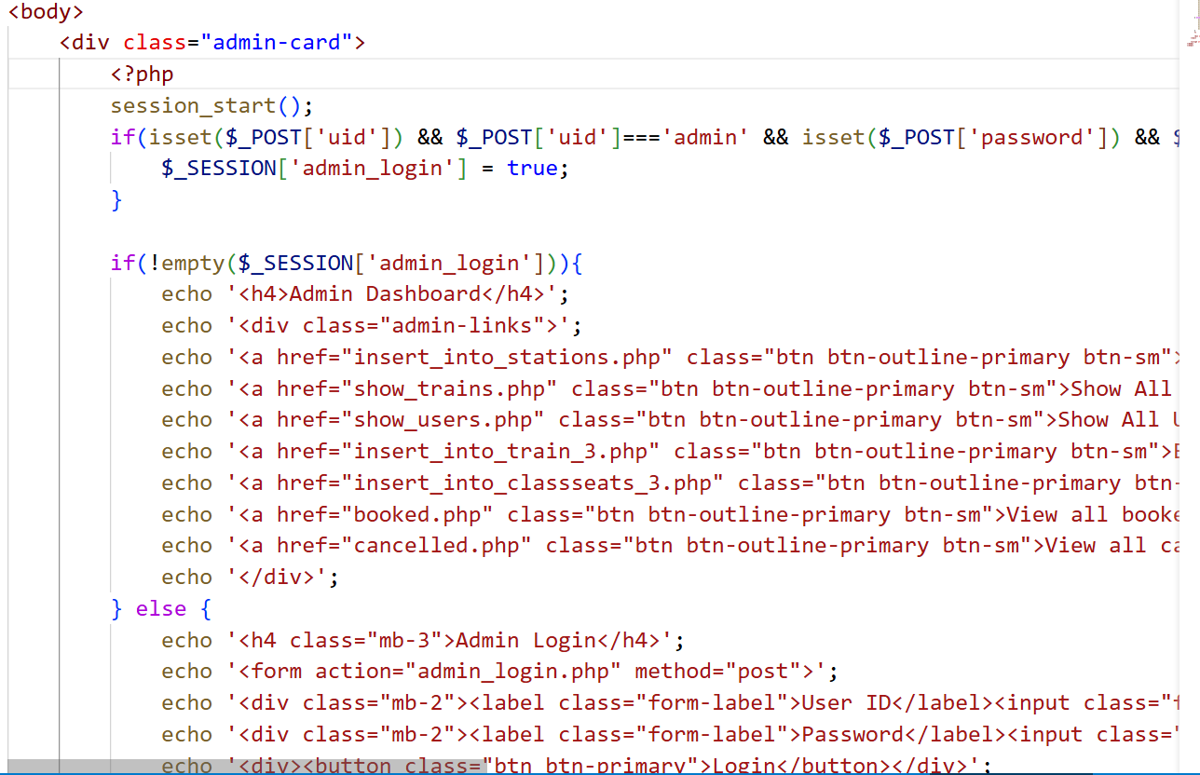
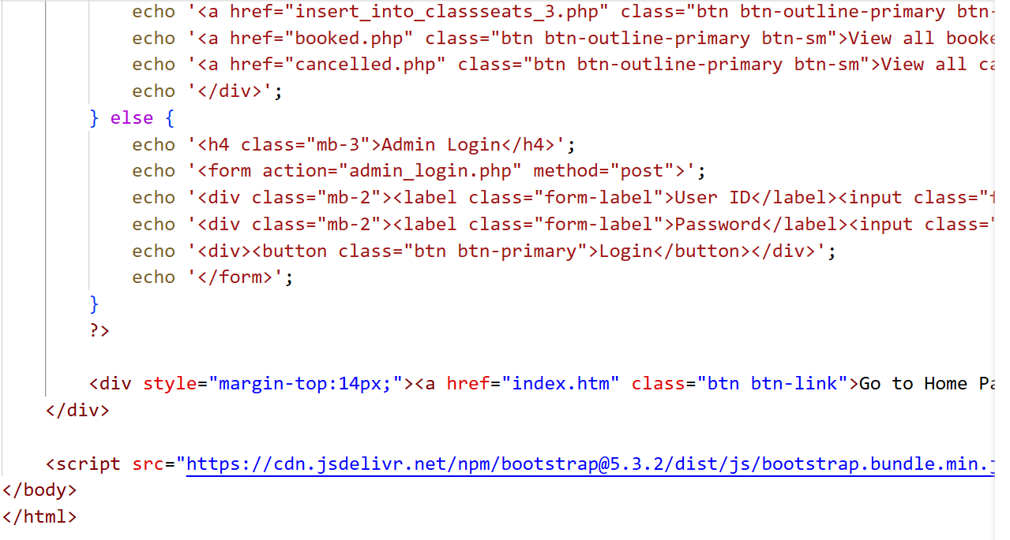
Receiving Login Credentials
- The system checks whether the HTTP request contains POST parameters:
  - uid (admin user ID)
  - password
- These values are submitted from the admin login form.
Admin Authentication
- The entered credentials are compared with predefined admin credentials:
  - User ID: admin
  - Password: admin
- If both values match:
  - A session variable $_SESSION['admin_login'] is set to true.
  - This indicates that the admin has been successfully authenticated.
Session Validation
- The system checks whether the session variable admin_login exists and is not empty.
- If the session is valid:
  - The admin is considered logged in.
  - The system proceeds to display the admin dashboard.
Displaying Admin Dashboard
- Once logged in, the admin dashboard is shown.
- The dashboard provides navigation links to administrative functions, including:
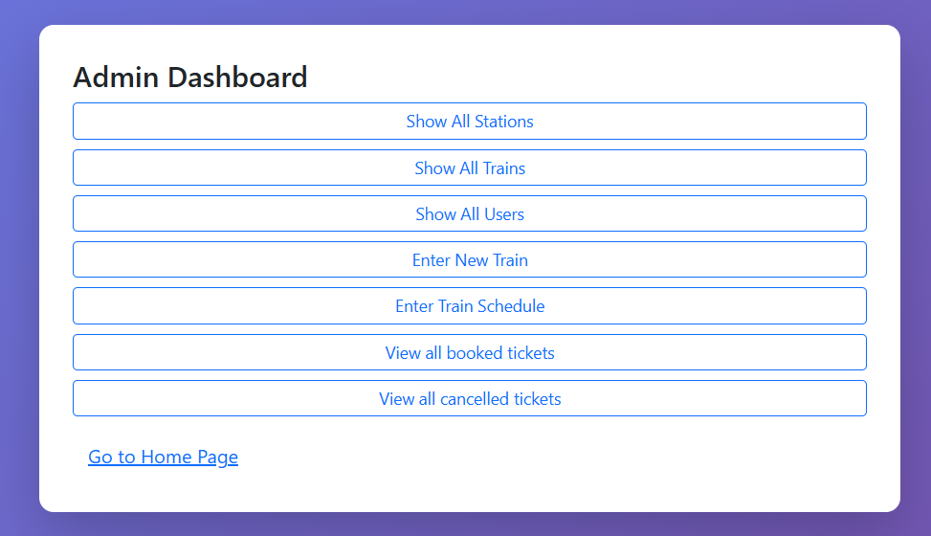
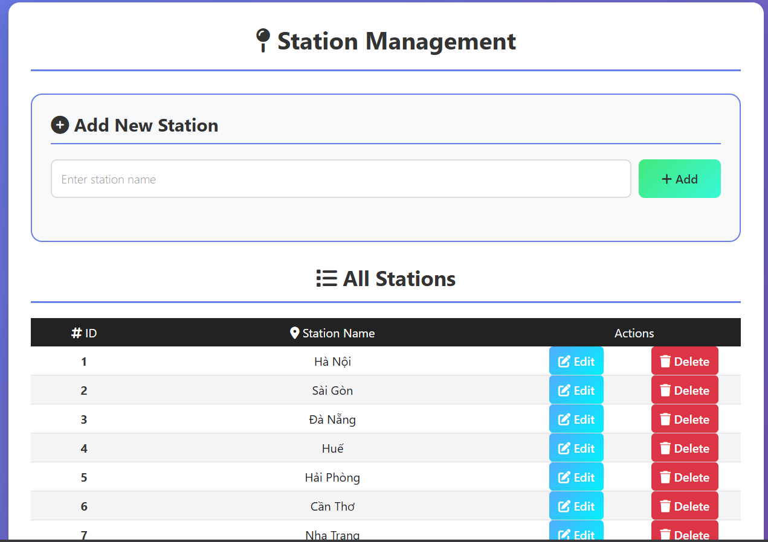

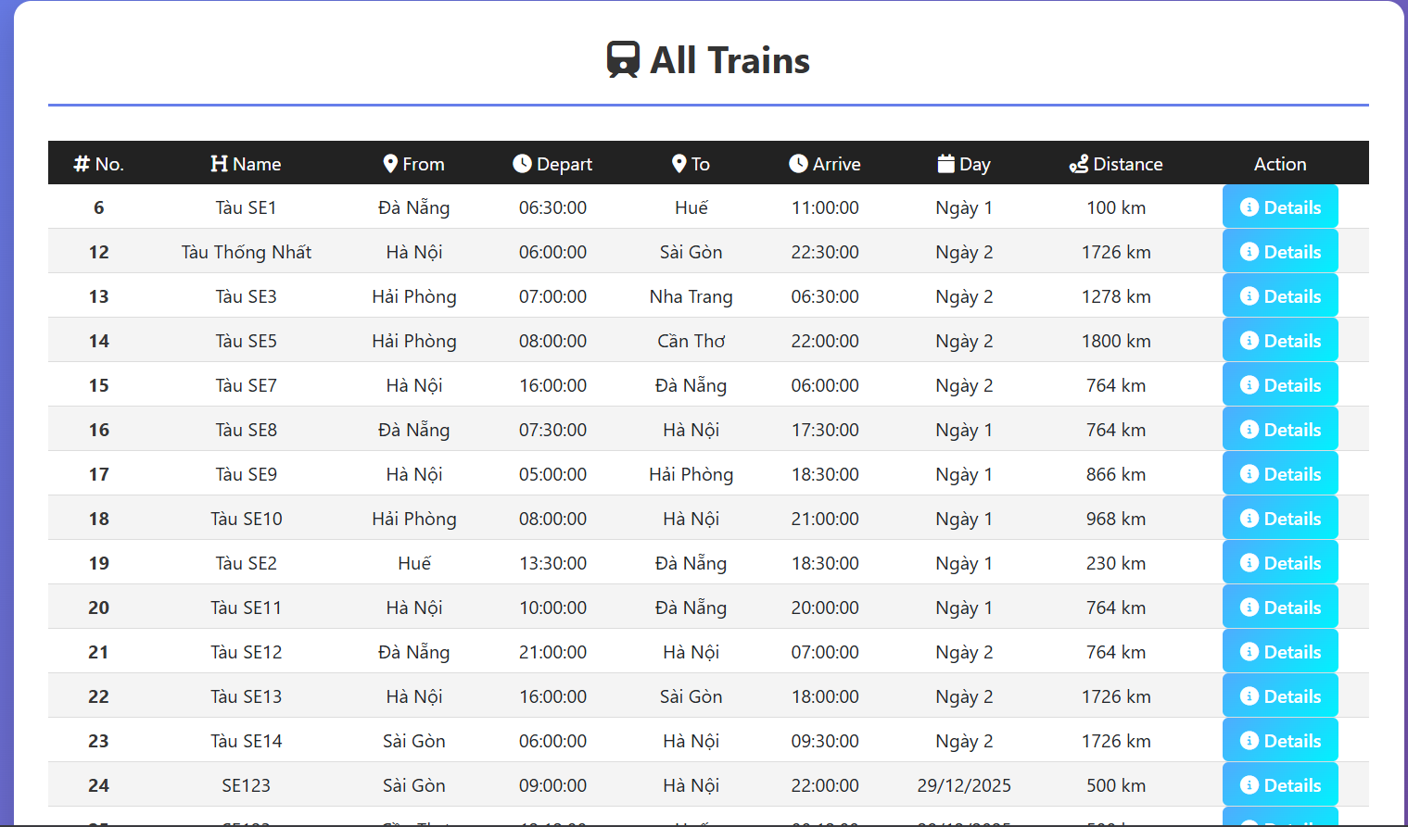
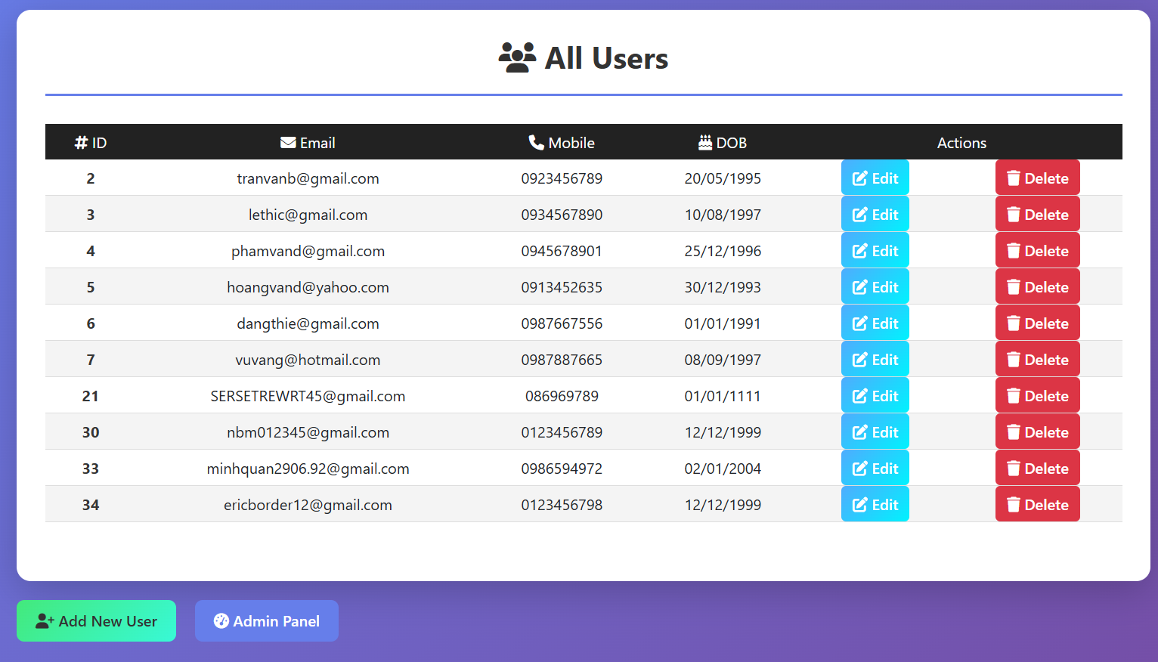
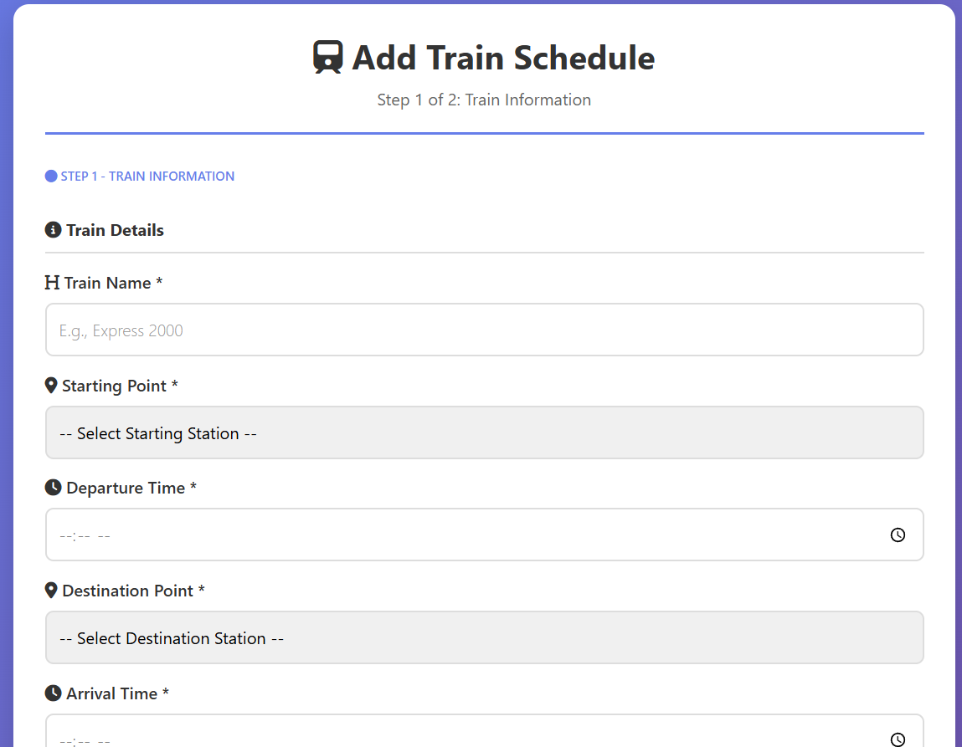
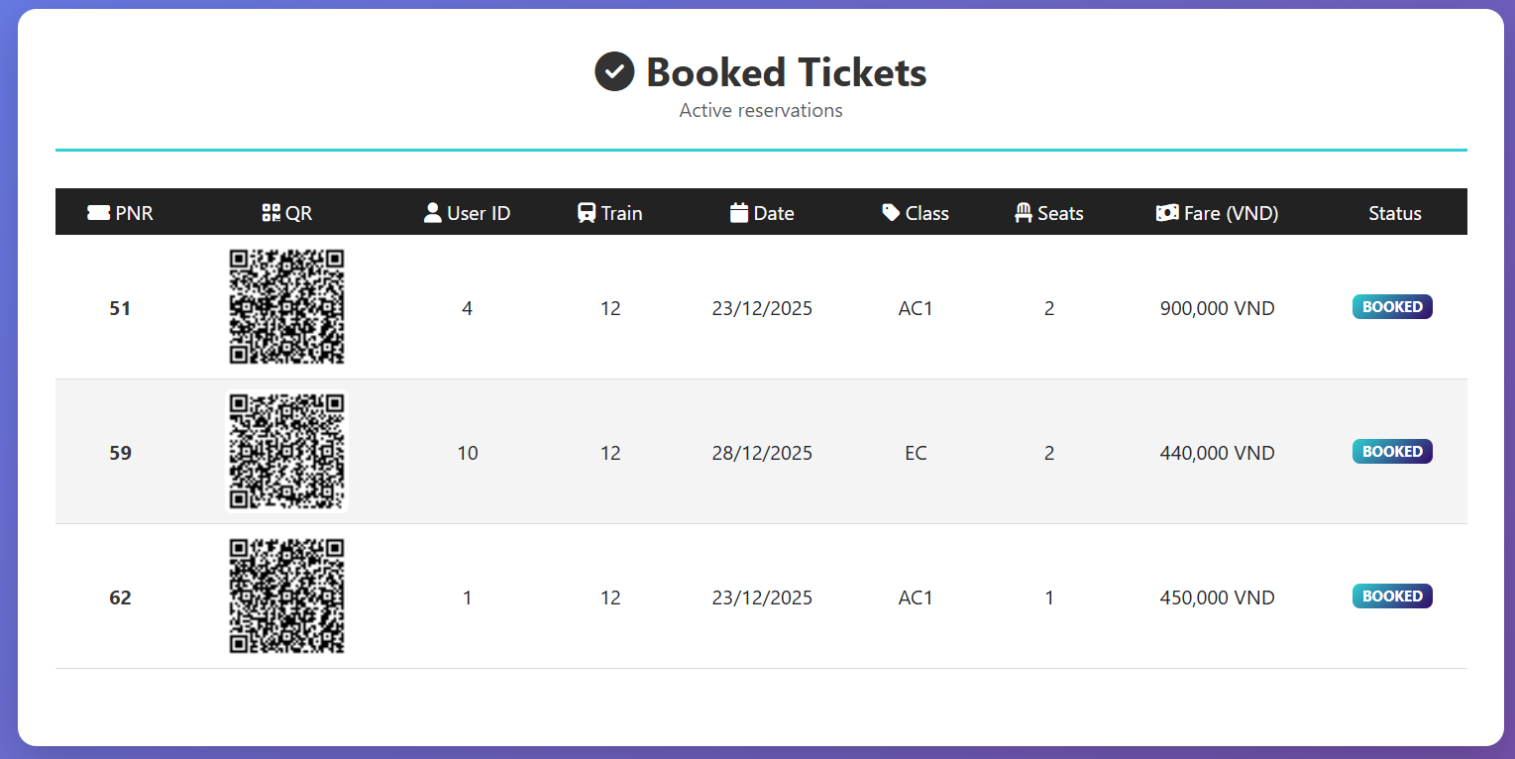
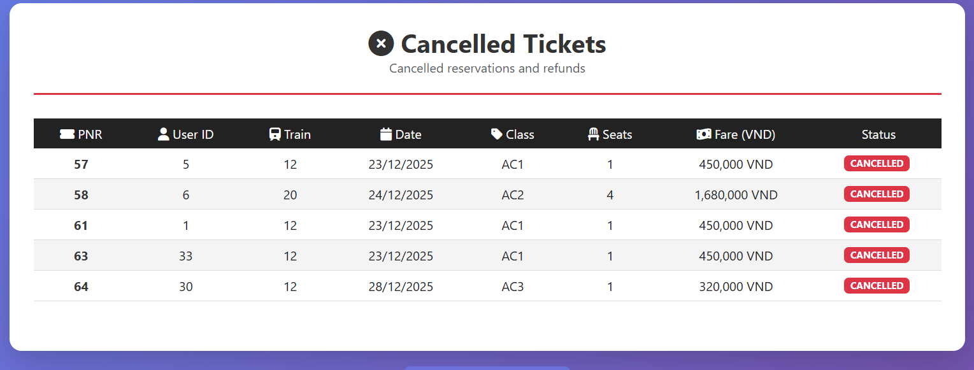
Handling Unauthenticated Access
- If the session variable admin_login is not set:
  - The admin login form is displayed.
  - The form requires the admin to enter a user ID and password.
  - The form submits data back to admin_login.php using the POST method.
Navigation Back to Home Page
- Regardless of login state, a link to the home page (index.htm) is displayed.
- This allows users or admins to return to the main application page easily.
V. Discussion & Conclusion
1. Achievements
Implemented an end-to-end booking flow: enquiry → booking → passenger → payment → tickets → cancel.
Improved UI and clean layout.
QR payment meets requirement uses internal qr.png (not external URL).
My Tickets show payment status per PNR.
Trigger ensures consistent seat restoration and refund rules.
2. Limitations
Payment is simulated (no real payment gateway integration).
Session-based flow depends on correct navigation order.
Admin and user roles may not be fully separated if not implemented.
3. Future Enhancements
Add “Confirm Payment” to update PENDING → PAID and store paid timestamp.
Restrict viewing ticket details if payment is not PAID (optional).
Improve security: hash passwords, stricter validation, CSRF protection.

VI. References
PHP Manual – MySQLi Prepared Statements
MySQL Documentation – Triggers and Constraints
Bootstrap 5 Documentation
ChatGPT

